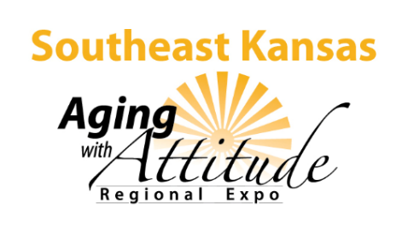
Aging with Attitude Regional Expo in Iola offers information, resources

K-State Research and Extension teaming with community partners on April 27
March 15, 2018
IOLA, Kan. — Life comes in stages – the early years of growing and education, the middle years of working and maybe raising a family – and the later years, which can be even more challenging and more fulfilling than the earlier stages.
K-State Research and Extension is teaming up with community partners to offer an “Aging with Attitude Regional Expo” to connect Kansans in the southeast part of the state with information and resources on Friday, April 27 in Iola. The event includes presentations, lunch, prizes and a resource fair from 9:00 a.m. to 3:30 p.m. at the St. John’s Parish Center, 315 South St., Iola.
Topics including “Living with Less”; “Intimacy in Later Life”; “Medicare Part D”; “Veteran’s Benefits”; “Have the Talk of a Lifetime”; ‘Stay Strong Stay Healthy’; ‘Health Benefits of Dance’ and others are on the agenda.
Erin Yelland, assistant professor at Kansas State University will deliver the keynote address, “So Now What? Picking Up the Pieces in Later Life.” Yelland, a K-State Research and Extension specialist in adult development and aging specializes in health and wellness across the lifespan, plus advance healthcare planning and Alzheimer’s Disease and dementia.
More information is available online at the Southeast Research-Extension Center Aging Expo page or by calling a local extension office or Gayle Price at 620-820-6123.

