Press Release 2017

Aging With Attitude workshop scheduled for April 28
Inspiration, health-care fraud prevention and pain management through exercise will be featured
Released: March 31, 2017
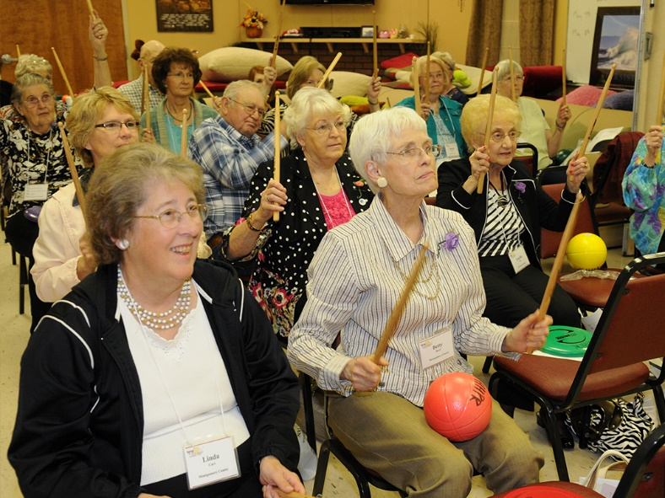
PARSONS, Kan. –People approaching their golden years – as well as their families, friends and caregivers – are invited to the 2017 Aging with Attitude Regional Expo April 28 at St. John’s Parish Center in Iola, Kansas.
The expo is a collaborative effort between K-State Research and Extension – Southeast Area, Allen County Regional Hospital, Senior Life Solutions, Harry Hynes Memorial Hospice, Iola Pharmacy, Medicalodges, Inc., Southeast Area Agency on Aging, and the Southeast Kansas Library System.
“The purpose of the Aging with Attitude Expo is to provide adults with education on issues and knowledge of community resources that support physical, mental and financial health,” said Gayle Price, family and consumer sciences specialist for K-State Research and Extension’s Southeast Area Office.
The keynote speaker, Rebecca French, is a health-care professional and author. She will share her inspirational story highlighting her book, OPA: From Hitler Youth to American Father and Farmer. Scott Fehr, a physical therapist with Allen County Regional Hospital, will lead a short session to promote increased physical activity. Gary Palmer, a professional photographer, will offer suggestions for preserving and archiving family photos.
“This year, the sessions include an overview of wills, trusts, powers of attorney and the other legal documents that become even more important as one ages,” Price said.
“Additional topics include driving safely, pain management through exercise, volunteerism and tips for helping seniors navigate social media, for those that want to take that plunge.
“We also have a class on avoiding Medicare fraud, which costs taxpayers billions of dollars every year,” Price added.
The advance registration fee includes lunch, the Staying Strong activity sessions, prizes and a resource fair.
A detailed agenda and registration form can be found at www.agingexpo.ksu.edu. Registrations received by April 17 are $15; late registrations after that date are $25, and lunch is not guaranteed. For questions, contact Gayle Price at 620-820-6123 or contact your local extension office.

