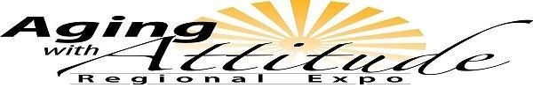

November 01, 2017

Plans are being made for the 2018 “Aging with Attitude Regional Expo” to be held on Friday April 27 in Iola, Kansas! The Aging with Attitude Regional Expo promotes positive attitudes about aging and educates older Kansans on issues that support physical, mental and financial health.

Kansas State University Research and Extension professionals along with the Allen County Regional Hospital, Angels Care Home Health, Harry Hynes Memorial Hospice, Iola Pharmacy, Medicalodges, Inc., Southeast Kansas Library System, SEK Area Agency on Aging, Thrive Allen County, and St. John’s Catholic Church, Iola, are planning the 2018 Expo which will focus on the many aspects of successful aging and caregiving.

The “Aging with Attitude Regional Expo” is planned and organized to:
- reach older adults, families and caregivers;
- provide education on aging issues for residents in the area;
- collaborate and create awareness of resources and agencies which are available to help the public with aging issues.

If your business, agency, or organization has similar goals or interests and would like to support this event, following are suggested opportunities of need:
_____ Financial contributions for:
- lunch meal
- snack break
- keynote speaker
- breakout sessions
_____ Provide a door prize appropriate for audience
_____ Participant Scholarships

All contributors will be listed in the on-site program materials. Sponsorships of $100 or more will also be acknowledged during the Expo and will be provided one free exhibit space, if requested. To learn more about Aging With Attitude please visit: www.agingexpo.ksu.edu or contact Barbara Stockebrand at 620-625-8620 or bstockeb@ksu.edu.

If your business or organization would like to support the 2018 Aging With Attitude Regional Expo, please make checks payable to Kansas State University (KSU) and mail to:
K-State Research and Extension
c/o Karen Walters
P. O. Box 316
Parsons, KS 67357

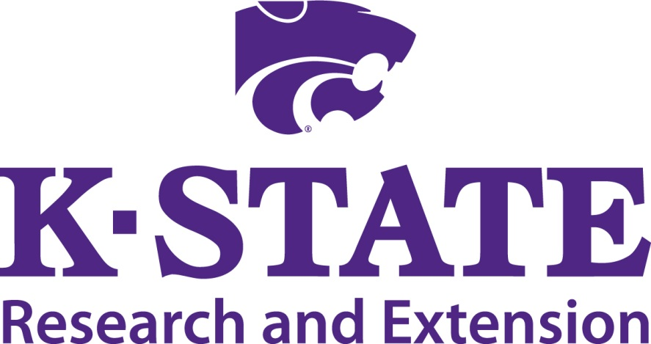

Aging with Attitude Regional Expo
April 27, 2018
Iola, Kansas

“K-State Research & Extension is an equal opportunity provider and employer.”

